# **Tethered Oral Tissues (Lip and Tongue Ties)**

Tethered oral tissues (TOTS) are bands of tissue that can restrict movement of parts of the mouth and thereby decrease the extent of functional movement of a person’s lips and tongue. This is termed a “tie” (lip tie or tongue tie) or in medical terms, “ankyloglossia.” Current understanding is about 5-10% of the population can be affected by tethered oral tissues, but that number is increasing as knowledge and diagnosis is expanding. Here are some things to know about tethered oral tissues.

## Everyone has a frenum! (Not everyone has tethered oral tissues).

The culprit for tethered oral tissues is a band of connective tissue called a frenulum, which serves a purpose – it is supposed to help prevent TOO much movement of flaps of tissue that would otherwise move, especially during embryonic development. In some people, this band of tissue is not fully removed by the body during development and results in tissues that are tightly attached (tethered) that are not supposed to be attached. (Similar to webbed fingers or toes). In certain people this can pose functional issues related to the movement of the lips and tongue.

## Does my baby’S Frenum need A revision or Release?

Not all frenulum’s need to be released! A frenum can be compared to shoelaces tied together. Some people have long laces that do not hinder movement or stretchy laces that do not hinder function. Other people have short, non-stretchy laces that would make it difficult for someone to walk, let alone run a mile. To tell if our patients need a frenum release, we do a functional assessment of their anatomy to explore the limits of motion of the tongue and lips and integrate that information with a symptomatic assessment of any reported issues related to the function of the tongue and lips.

## What benefits are there to releasing a tethered tongue/lip?

The functional benefits to releasing tethered oral tissues are to allow a larger range of motion for these structures. This has as many effects as there are functions of the tongue and lips! For example:

1. **Breastfeeding**: More efficient, less painful, less difficult, less tiring, less gas.
2. **Diastema**: A midline gap between the teeth (especially those that are the only ones) are in many cases due to a severe lip tie, which if released can allow the front teeth to touch and help keep them touching.
3. **Speech**: easier articulation of tongue sounds —such as “t,” “d,” “l,” “th,” and “s”
4. **Feeding**: Increased bolus (food ball) control, less gas, better swallow pattern.
5. **Posture**: Proper tongue posture is easier to achieve (tongue should rest behind the front teeth and along the palate, with teeth slightly separated).
6. **Development**: Upper jaw and palate development is dependent on tongue pressure (i.e. tongue range of motion) to create adequate circumference and size of the bones holding the teeth.
7. **Airway**:Proper tongue posture and development of the maxilla lead to better breathing (silent breathing through the nose) and less resistance (better airflow) through the airway.

# **Frenectomy pre/post op instructions**

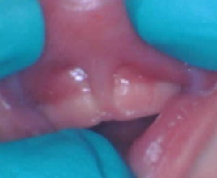**General information**

* Close up of a person's tongue

  Description automatically generated with medium confidenceA close up of a person's tongue

  Description automatically generated with medium confidenceA frenectomy is a surgical procedure that releases the tightened tissues to allow movement of the tongue but requires stretching post-operatively to ensure proper healing of the tissue and minimize harmful scar formation and reattachment.

**Pre-operative information**

* Assessment for lip/tongue tie must be completed by one of our trained doctors, but we also work closely with lactation consultants and other professionals to increase the chances of a successful outcome. A referral from a lactation consultant, speech pathologist, or pediatrician is preferred before lip/tongue revision is completed.
* Pain medication given prior to the procedure may be used, but is not needed for everyone, as a small amount of topical anesthetic is used. Tylenol given 2 hours before the appointment can help to minimize discomfort, using the dosing on the packaging:
  + 6-11 lbs: 1.25mL 18-23 lbs: 3.75 mL
  + 12-17 lbs: 2.5 mL 24-35 lbs: 5 mL
* Bring a comfortable blanket with which to swaddle your baby and buy coconut oil for post-operative stretching.

**What to expect during the procedure**

* This procedure is generally tolerated very well by newborns, as we take every measure to ensure pain and stress during the procedure is minimized. General anesthesia is not used.
* Due to laser safety regulations, parents are not allowed in the treatment room during the procedure. Your child will be carried, swaddled, to and from the room, and your child will be away from you for less than 10 minutes.
* Inside the room, your child will receive an age-appropriate amount of topical numbing medicine that, depending on age, may be rubbed on or injected around the area we will be working to minimize discomfort. Crying/fussing is common during and after the procedure.
* The tissue is then surgically released with a laser
* After the procedure is complete, we will deliver your child to you, and you may sooth the baby in any manner you like. **We recommend feeding/breastfeeding immediately for a newborn.**

**Risks:**

* Pain – most babies experience only minimal discomfort after the procedure, but Tylenol may be given to help.
* Bleeding – some bleeding 1-2 days after the procedure is normal, but the bleeding should not be severe. You may notice dark streaks of blood in your baby’s diaper from blood swallowed during the procedure, or a small amount of blood on your baby’s pillow. This is not a cause for concern. Soaking a gauze or pillowcase warrants a call to your doctor.
* Other burns on the lips or tongue: although every effort is made to ensure it does not happen, the potential for small burns or cuts are unavoidable since babies don’t understand the need to stay still during the procedure. These heal quickly and do not cause lasting damage.

**Post operative information**

* The most important thing to understand is that for proper healing and minimal harmful scar tissue formation to occur, you MUST STRETCH THE WOUND. This is key to obtaining an optimal result and reducing the risk of the tissue reattaching. **If you do not do the stretches, the mouth heals so quickly that it may prematurely reattach at either the tongue site or the lip site, causing a new limitation in mobility and the persistence or return of symptoms**.

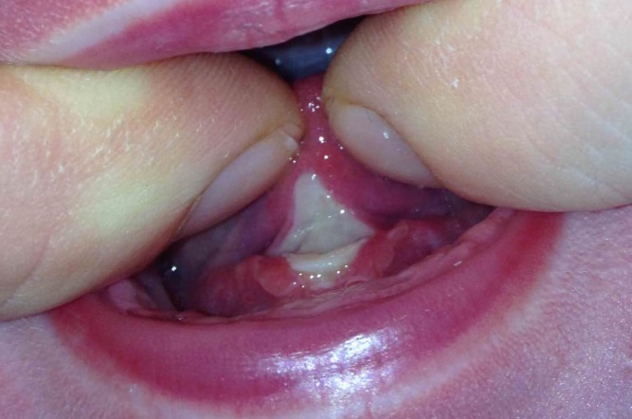

* Preparation/position for post-operative stretching:
  + Clean hands with soap and water (gloves are not necessary)
  + Lay your baby down in your lap on a bed. It is easiest to approach from above the head with your child’s feet going away from you, and use your legs to stabilize your child’s body.
  + Apply a small amount of coconut oil to your fingers. The oil helps to lubricate and heal the wound, and is safe.
  + **You may expect a small amount of bleeding in the first few days after the procedure and some fussing/crying/discomfort from baby during the stretches. If baby is resisting, try again later.**
  + **Stretches are to be done 4-6x/day for 3 weeks, and tapering from 5-1x/day over week 4 and quitting after week 4.**
* Lip Stretches:
  + Place your finger under the upper lip and move it up as high as it can go. Sweep from side to side with your oiled fingers. The goal is to unfold the diamond so the raw, opposing surfaces cannot stick together.
* Tongue stretches: See Dr. Ghaheri’s videos at <https://vimeo.com/98709935>
  + Place your two index fingers or thumb and index finger under the tongue raising the tongue up and back towards the roof of the mouth. The goal is to stretch the “diamond” vertically so it is not folded on itself and flat. The ideal stretch is one where the left corner/edges and right corner/edges of the wound meet in the middle. Hold in this up and back position for 1-2 seconds.
  + Massage the wound so the left and right corners of the diamond come together with your oiled fingers.
  + It is normal to see a white or yellow patch where the wound is. It is the body’s way of healing this area.
* Follow-up:
  + Please follow up with your lactation consultant or other related care providers. Full benefits of this procedure may not be experienced until 4 weeks after the procedure. Please follow up with us at 1 week and 4 weeks.
* Call our office if the following:
  + Uncontrolled bleeding (not just spotting, but soaking gauzes)
  + Refusal to nurse/feed
  + Fever > 101.5°

*Credit: Dr. Bobby Gaheri